# Coursera Applied Data Science Capstone Project

# **Determining location for opening a new Asian Restaurant**

# By: Shraddha Gurav

# May 2021

1. **Introduction**

Asian food has acquired popularity across the world and the main reason for this is the taste that food offers. It offers you so many types of dishes that will satisfy your hunger buds and will also keep you healthy. Apart from being tasty and healthy, it is much cheaper and won't burn a hole in your pockets.

Asian cuisine has so many options - Central Asian, East Asian, South Asian, South East Asian, West Asian. The Asian cuisine is very popular that the restaurants are established in so many countries around the world. You can enjoy the taste from anywhere in the world. Toronto also has some good restaurants which offer Asian food.

So, the idea of this study is to help people who are planning to open a new Asian restaurant in Toronto, to choose the right location by providing data about each neighbourhood. The study will also help those who are interested in trying different types food by providing them different options of dining at an Asian Restaurant.

Prior launching any restaurant, it’s important to know if the business has a good opportunity. In order to do so, the factors we have to take into consideration are as follows,

* Market Places
* Competition in particular location
* Aiding places that make people come to restaurants like Gym, Entertaining Public places
* Population
* Menu from competitors
* Income of people residing in the neighbourhood

All this data will be used for further analysis.

1. **Data**

To solve this problem, we will need following data:

* Toronto city data containing the boroughs and neighborhoods
* Latitude and Longitude coordinates of those neighborhoods. We require the coordinates to plot on map.
* Venue data that is latitude, longitude, name and category type of the venues.

We are using Toronto Neighbourhood Data to get to know about the various neighbourhoods.

Data source: <https://en.wikipedia.org/wiki/List_of_postal_codes_of_Canada:_M>

To get a better understanding of the neighbourhoods and their corresponding locations, we will implement the Folium map.

This project will use Four-square API along with the above data source, which has data about the various (Asian) restaurants in each neighbourhood of Toronto, especially their places API which provides the ability to perform location search, location sharing and details about a business.

After acquiring the data from mentioned data set, it will be filtered for the required data acquired from Foursquare which is only about Asian Cuisine.

Further data analysis will be done using the filtered dataset.

1. **Methodology**

Data for neighbourhoods and boroughs is collected from <https://en.wikipedia.org/wiki/List_of_postal_codes_of_Canada:_M>.

‘BeautifulSoup’ library is used for Web Scarping. With web scraping data can be extracted, parsed, downloaded and organized to get useful information from the web automatically. Data extracted using Web scraping is extracted into Pandas DataFrame. Since we need latitude and longitude coordinates for neighbourhoods, those can be obtained from the CSV file. The CSV file used is <https://cf-courses-data.s3.us.cloud-object-storage.appdomain.cloud/IBMDeveloperSkillsNetwork-DS0701EN-SkillsNetwork/labs_v1/Geospatial_Coordinates.csv>

The neighbourhoods and boroughs data are merged with latitude and longitude data to form a dataframe which will be used in further analysis.

Foursquare API is used to locate all venues for the neighbourhoods in Toronto. This new data obtained from Foursquare is extracted into dataframe. It contains Neighbourhood Latitude-Longitude coordinates, Venue, Venue Latitude-Longitude Coordinates and Venue Category.

After we get a consolidated dataframe with all the required data, we perform analysis on this data.

Firstly, with the help of matplotlib.pyplot library, we plot the graph to check which is the most popular borough where majority of different types of venues are located. Once we get idea about the most popular borough in Toronto, we continue with further analysis.

Since our objective is to find suitable location for opening new Asian restaurant, we filter out our data to get only restaurants which are in Toronto.

After we get the dataframe with the Restaurant data, we plot this information to check the **Restaurants per Borough and Restaurants per Neighbourhood.**

**Finally, we filter out the data to minute level, in order to obtain already existing Asian restaurants in Toronto. Once the filtered dataframe is formed, this dataframe is used to perform final analysis. Using new dataframe, we can plot number of Asian Restaurants per borough and per neighbourhood.**

Folium map is used to plot the restaurants data and Asian restaurants data which helps with visualization.

1. **Results**

Results of the analysis is as follows:

* 1. Plot for Number of Venues per Borough

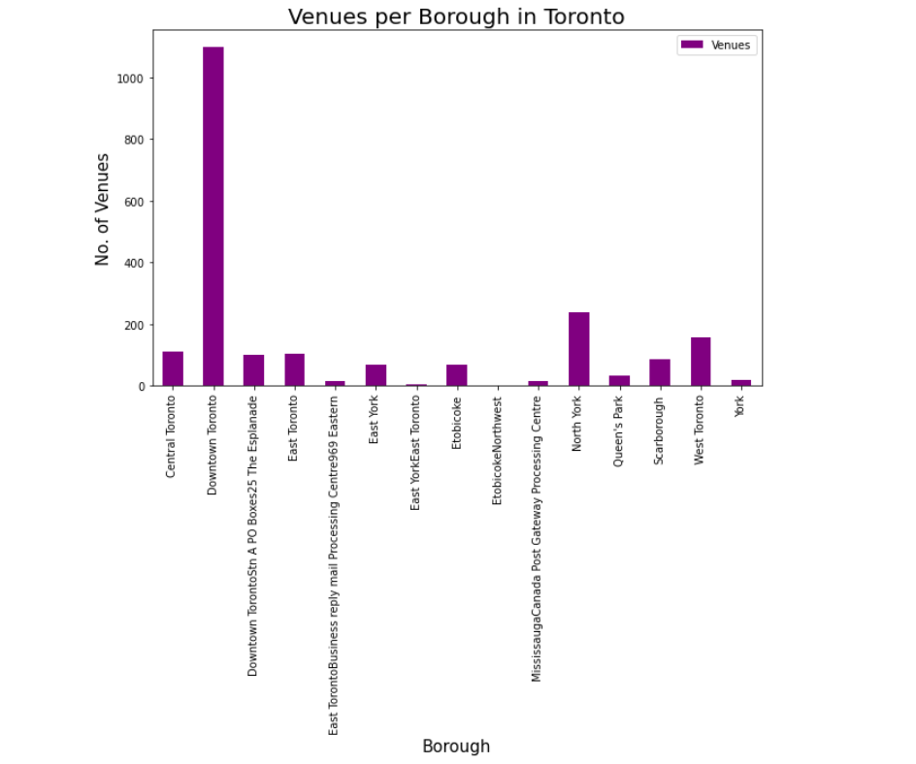

Above plot shows, Downtown Toronto is the most popular borough in Toronto with maximum number of venues located while Etobicoke is the least popular.

* 1. Here we filter our dataframe to get only restaurant data

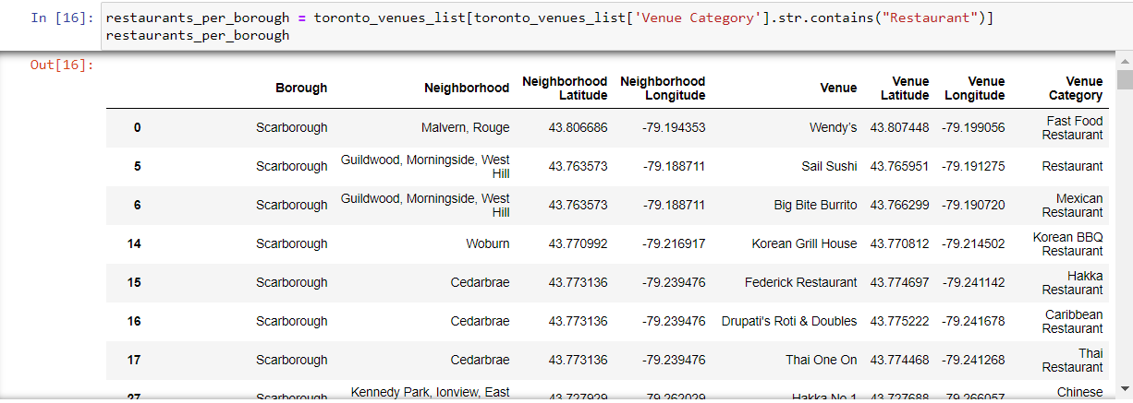

* 1. Plot for Restaurants per Borough in Toronto

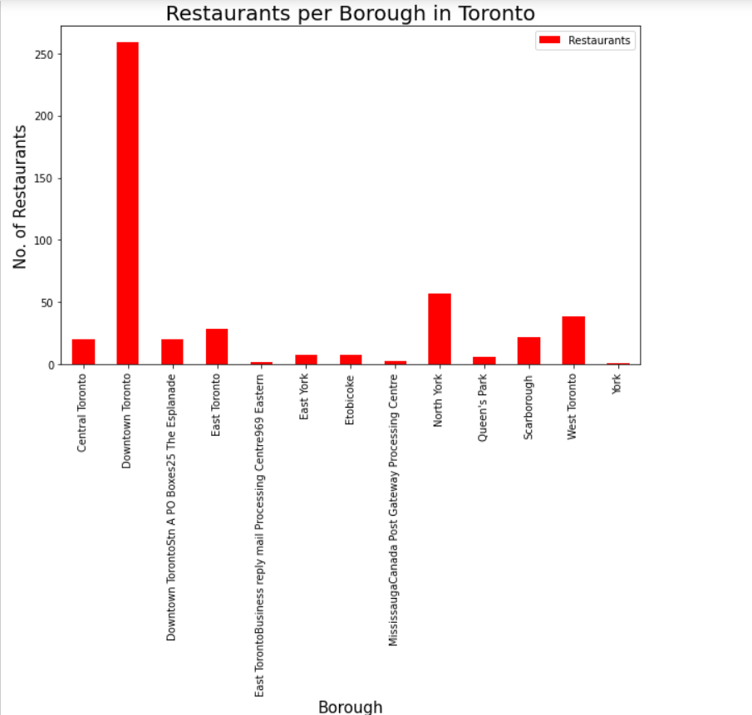

As we already know, Downtown Toronto is the most popular borough in Toronto; it also has the highest number of restaurants. Thus, it is clear that Downtown Toronto is the populated borough with multiple attractions and hence it is expected to have variety of restaurants.

* 1. Plot for Restaurants per Neighbourhood

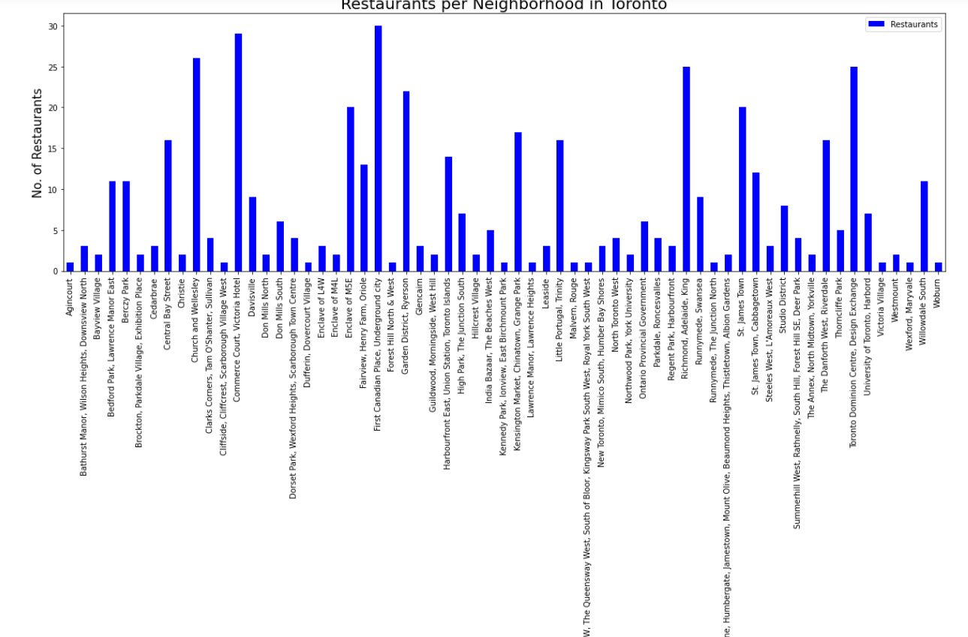

Since Downtown Toronto has highest number of restaurants, it is pretty much evident that the top five neighbourhoods with highest number of restaurants namely, First Canadian Place, Underground City; Commerce Court, Victoria Hotel; Church and Wellesley, Richmond, Adelaide, King; Toronto Dominion Centre, Design Exchange are from Downtown Borough.

* 1. Plot for Asian Restaurants per Borough

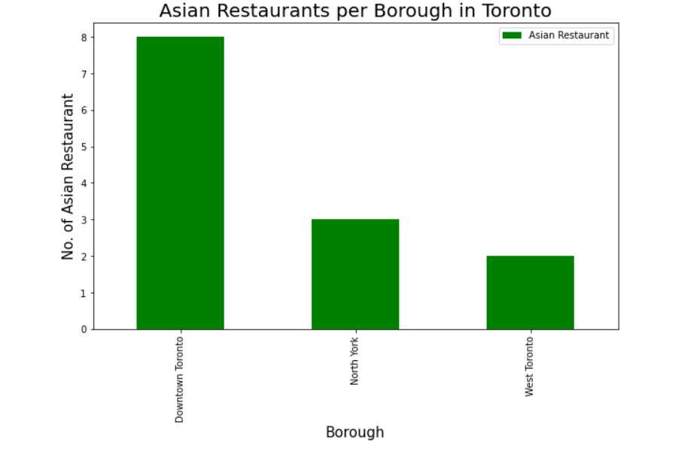

Our aim is to find suitable location for opening an Asian Restaurant. So, from the above plot we can say that West Toronto is ideal location for establishing new Asian restaurant as it has only few options available. But it seems Downtown Toronto is popular amongst people for dining at Asian Restaurant as it has maximum number of them.

* 1. Plot for Number of restaurants per neighbourhood

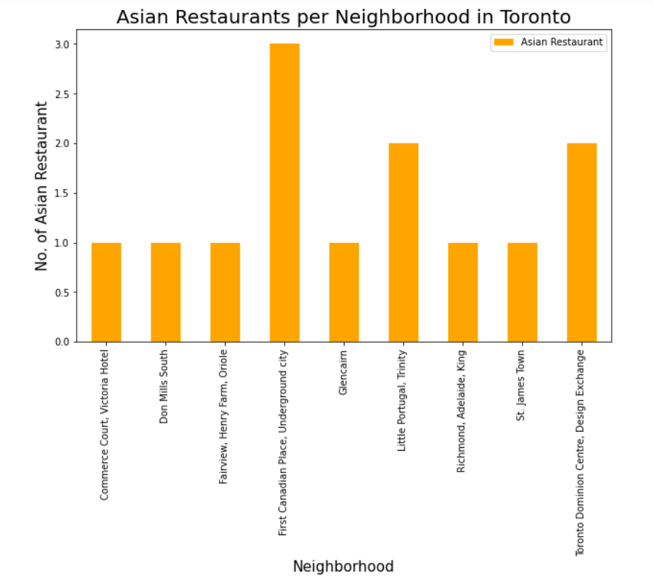

This plot shows First Canadian Place is most popular for Asian Restaurants. So, if we are concerned with popularity of area, First Canadian Place, Underground City is ideal place to open new Asian Restaurant.

But on the other hand, the new establishment will have to face competition from its counterparts. To avoid that, we can choose neighbourhood with least number of restaurants to provide people with new place to enjoy Asian cuisine. Some of the neighbourhoods are Commerce Court, Don Mills South, Fairview, Glencaim, St. James Town, etc.

1. **Discussion**

Based on the results of our analysis, Downtown Toronto have multiple neighbourhoods with good number of restaurants which suggests that people ideally choose any of the neighbourhoods from this borough for dining. On the contrary, neighbourhood in West Toronto have good possibility for opening new Asian Restaurant as it has only few in the neighbourhood of Little Portugal Trinity. Thus, opening a new Asian Restaurant in West Toronto will provide people with another option to try Asian cuisines.

1. **Conclusion**

In this project, we have performed data extraction, data pre-processing before performing the analysis. We have extracted data from different data sources, transformed extracted data into dataframes, filtered required data, merged different dataframes, performed data analysis and lastly provided recommendations based on the analysis carried out. We used different python libraries to perform this task. The findings of this project will help investors to understand in a better way, the advantages and disadvantages of different boroughs and neighbourhoods of Toronto in order to open new Asian Restaurant.